

**Experiment No.**

**3**

**Title:** Implementation of Informed search algorithm- A*

**Batch: B1 Roll No.:1914078 Experiment No.: 3**

**Aim: To Implementation of Informed search algorithm- A* Resources needed: Internet**

**Theory**

The most widely-known form of best-first search is A*(pronounced “A-Star search ”). It evaluates nodes by combining g(n), the cost to reach the node, and h(n), the cost to get from node to goal:

# f(n) =g(n)+h(n)

Since g(n) gives the path cost from the start node n, and h(n) is the estimated cost of the cheapest path from n to the goal, we have

f(n)=estimated cost of the cheapest solution through n.

The pleasant thing about this strategy is that it is more than just reasonable. The restriction is to choose an *h* function that *never overestimates* the cost to reach the goal. Such an *h* is called an **admissible heuristic** can actually prove that it is complete and optimal, given a simple restriction on the *h* function.

In other search we minimizes the estimated cost to the goal, *h(n),* and thereby cuts the search cost considerably. Unfortunately, it is neither optimal nor complete. Uniform-cost search, on the other hand, minimizes the cost of the path so far, *g(ri);* it is optimal and complete, but can be very inefficient. It would be nice if we could combine these two strategies to get the advantages of both. Fortunately, we can do exactly that, combining the two evaluation functions simply by summing them: f(n) = g(n) + h(n).

So A* is the best search for minimizing the total estimated solution cost.

A* algorithm is a typical heuristic search algorithm, in which the heuristic function is an estimated shortest distance from the initial state to the closest goal state, and it equals to traveled distance plus predicted distance ahead.

That is, f(n) = g(n) + h(n).

1. Create a search graph, G, consisting solely of the start node N1. Put N1 in a list called OPEN.
2. Create a list called CLOSED that is initially empty.
3. If OPEN is empty, exit with failure.
4. Select the first node on OPEN, remove it from OPEN, and put it on CLOSED. Call this node N.
5. If N is a goal node, exit successfully with the solution obtained by tracing a path along the pointers from N to N1 in G. (The pointers define a search tree and are established in step 7.)
6. Expand node N, generating the set, M, of its successors that are not already ancestors of N in G. Install these members of M as successors of N in G.
7. Establish a pointer to N from each of those members of M that were not already in G (i.e., not already on either OPEN or CLOSED). Add these members of M to OPEN. For each member, Mi, of M that was already on OPEN or CLOSED, redirect its pointer to N if the best path to Mi found so far is through N. For each member of M already on CLOSED, redirect the pointers of each of its descendants in G so that they point backward along the best paths found so far to these descendants.
8. Reorder the list OPEN in order of increasing f values. (Ties among minimal f values are resolved in favor of the deepest node in the search tree.)

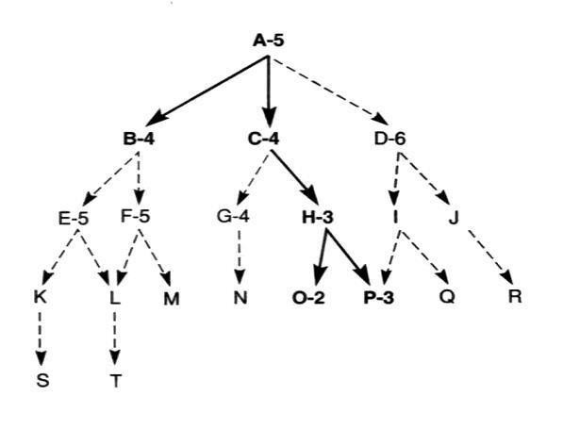

1. Go to step 3.

# Figure 1. Example of Algorithm

**Algorithm :**

1. Put the initial node on SvTART.
2. If START = Empty or START = Goal, Terminate.
3. Remove first node from START as „a‟.
4. If (a=Goal), Terminate with success.
5. Else if „a‟ has successors, generate all of them. Estimate the fitness number of successors by totaling evaluation function value and cost function value. Sort the this list by fitness number.
6. Replace START with this new list.
7. Go to step 2.

# Procedure:

* 1. Implement A* algorithm as discussed for graph traversal
  2. Print the contents of fringe/OPEN , CLOSED/Visited and the solution.

# Results: (Softcopy submission of Summary Document)

# Code:

nodes=['S','A','B','C','D','Y','X','E']

a = [0,5,6,4,15,8,5,0]

c = [17,999,999,999,999,999,999,999]

xyz = {

  'S': ['A','B'],

  'A': ['Y','X'],

  'B': ['C','D'],

  'Y': ['E'],

  'X': ['E'],

  'C': ['E'],

  'D': ['E'],

  'E': []

}

dist = []

for i in range(len(nodes)):

    dist.append([0]*len(nodes))

for i in range(len(nodes)):

    for x in xyz[nodes[i]]:

        d = int(input("Enter distance of {} from {} : ".format(x,nodes[i])))

        y = nodes.index(x)

        dist[i][y] = d

        dist[y][i] = d

src = input("Enter the Source Node : ")

lastNode = input("Enter the last node: ")

visited = {}

distance = {}

main = {}

bfs_output = []

queue1 = {}

queue = []

for i in xyz.keys():

    visited[i] = False

    main[i] = None

    distance[i] = 99999

    queue1[i] = 99999

source = src

visited[source] = True

distance[source]= 0

queue1[source] = 17

queue.append(source)

v = 1

while len(queue)!=0:

    pop = queue.pop(0)

    queue1.pop(pop)

    bfs_output.append(pop)

    for i in xyz[pop]:

        tot = distance[pop] + dist[nodes.index(pop)][nodes.index(i)] + a[nodes.index(i)]

        if c[nodes.index(i)] > tot:

            visited[i] = True

            v+=1

            main[i] = pop

            distance[i] = distance[pop] + dist[nodes.index(pop)][nodes.index(i)]

            c[nodes.index(i)] = distance[i] + a[nodes.index(i)]

            queue1[i] = distance[i] + a[nodes.index(i)]

        queue.append(i)

        queue.append(i)

        sortedQueue = sorted(queue1.items(), key=lambda x: x[1])

        queue = []

        for j in sortedQueue:

            queue.append(j[0])

print(a)

path = []

print("Total Cost: ",distance)

print("Number of nodes visited: ",v)

while lastNode is not None:

    path.append(lastNode)

    lastNode = main[lastNode]

path.reverse()

print("Path taken",path)

# Output:

**Outcomes:**

**CO2:Analyze and formalize the problem(as a state space,graph,etc) and select the appropriate search method and write the algorithm**

**Conclusion: A* algrithm was studied and implemented.**

**Grade: AA / AB / BB / BC / CC / CD /DD**

**Signature of faculty in-charge with date**

**References:**

* Stuart Russell and Peter Norvig, Artificial Intelligence: A Modern Approach, Second Edition, Pearson Publication
* Elaine Rich, Kevin Knight, Artificial Intelligence, Tata McGraw Hill, 1999.